**CSE211 Web Programming, Fall Semester 24/25**

**Assignment #1: Websites Conceptual Design and mock-up**

**ID: 222100363 Name: Basel Mohammed Ahmed Hammad** **Major:CE**

**Part 1 Research**

1. Web 2.0 used in generating content and social networking. Web 3.0 brings sematic integration and data interoperability. Web 4.0 used advanced virtual reality and connects to the internet of things.
2. We have 7 key features of web2.0 and How it empowers the power of network
3. **Folksonomy:** It’s a traditional web like yahoo directory and it’s a system of tagging the users or adding keywords in online content. Examples: The photo sharing site Flickr and social Bookmarking.
4. **Rich User Experience:** It’s a traditional web are built with HTML and CSS, had been offered as a static page. Web 2.0 uses Ajax (Asynchronous JavaScript + XML), HTML5(for interactive video and audio) presenting dynamic, rich user experience to users. Examples: Google Provided Google Maps and Google Suggest.
5. **User As Contributor:** In the traditional web, the information is often provided by the site owner, and the user is always the reciever.The information model was one way. Web 2.0 users also contribute to the content by means of Evaluation, Review & Commenting. Examples: Amazon.com,Customer review section &Google’s Page Rank mechanism.
6. **Long Tail:** The traditional web was like a retail business the product is sold directly to user and the revenue generated. But in web 2.0 the niche product is not sold directly but offered as a service. Examples: Sales force CRM and Google Apps.
7. **User Participation:** It’s a traditional web the contents are solely provided by the site owner. But in web2.0 the users participate in content sourcing. Examples: Wikipedia & YouTube.
8. **Software as a service (SAAS):** involving human interactions with digital content facilitated by applications delivered over the web that free the user from locally installed software.
9. **Dispersion:** In traditional web, the contents were delivered as a direct site to home. But in web 2.0 content delivery uses multiple channels including permalinks file sharing. Examples: Bit Torrent and Mashup.

Then the power of networking: Web 2.0 created a higher level of information sharing and interconnectedness among participants. The second version of the Internet allows users to actively participate in the experience—rather than just acting as passive viewers who take in information.

3- We have 10 key features of web3.0 and how it empowers the meaning of data and knowledge connections.

1. Decentralization: It forms the bedrock of web3, shifting the control and ownership of data. Also, it promotes autonomy and security, it's not without challenges. Examples: Arweave,IPFS,Filecoin.
2. **User Sovereignty:** In web 3 is a revolutionary shift from the norms in web 2. It empowers the users with full control over their data allowing them to determine accesses and use. Examples: Ocean Protocol, SSI.
3. **Trustless and Permissionless:** This nature of web 3 redefines interactions on the internet. By leveraging cryptographic techniques and robust consensus mechanisms. This paradigm fosters a level of inclusivity and access previously unattainable. Examples: Bitcoin, OpeanSea.
4. **Native Payments:** Via cryptocurrencies are a cornerstone of web 3, offering a new financial paradigm. This innovation not only facilitates faster and more secure transactions. Examples: Lightning Network, Chain link's Decentralized Oracle Network.
5. **Interoperability:** This is a guiding principle of web 3, envisioning a seamlessly connected digital ecosystem. Achieving this level of interoperability without compromising security and user privacy is a formidable challenge. Examples: Aion Network and Cosmos.
6. **Consensus Mechanisms:** the engines of trust in web 3, facilitating agreement across decentralized networks. These mechanisms provide the foundation for secure and democratic systems. Examples:Algornad,Tezos.
7. **Smart Contracts:** It revolutionizes agreements by embedding the terms directly into code. The reliability of smart contracts is only as strong as the code they are written in, making them susceptible to bugs and vulnerabilities. Examples: Insurance app like (Nexus Mutual), Real Estate Transactions on Propy.
8. **Privacy by Design:** A fundamental aspect of Web3, embedding privacy into the architecture of systems from the ground up. Balancing this privacy with regulatory requirements, such as anti-money laundering laws, presents a complex challenge, requiring innovative solutions. Examples: Secret Network, Tornado Cash.
9. **Semantic Web:** It represents the next leap in making the internet more intelligent, enabling machines to understand and interpret data like humans do. Realizing the semantic web at scale involves significant technical challenges, requiring changes in how data is structured, stored, and processed. Examples: Knowledge Graphs in web3 projects, Sirius by Koii Network.
10. **Integration of Artificial Intelligence and Machine Learning:** Web3 promises to create a more adaptive, responsive, and personalized digital experience. These technologies have the potential to automate complex tasks, unearth insights from vast datasets, and foster innovation at an unprecedented scale. Examples: Fetch.ai, Ocean Protocol.

Web3 empowers the meaning of data and knowledge connections by decentralizing ownership, enhancing interoperability, and ensuring security and privacy. By enabling automated interactions through smart contracts and fostering user-controlled data monetization, it creates a more equitable data economy. Furthermore, the application of Semantic Web principles and the integration of AI and machine learning facilitate intelligent knowledge connections, transforming how data is utilized and understood in the digital landscape.

4- **We have 12 key features of web4.0 and how it empowers intelligent connections.**

1. **Artificial Intelligence (AI):** At the core of web four point zero is AI, which enables the internet to understand, learn, and adapt. AI systems can analyze user behavior, providing highly personalized and efficient online interactions. Example: Google Assistant.
2. **Big Data Utilization:** Web 4.0 harnesses the power of big data. Enormous volumes of data generated by users and devices are collected and analyzed to provide insights, improve services, and support data-driven decision-making.Example: IBM Watson
3. **Cloud Computing Integration:** Cloud computing is the backbone of web four point zero. It offers scalable and flexible resources for data storage and processing. This scalability is crucial to meet the increasing demands of a highly connected world.Example: Dropbox.
4. **Internet of Things (IoT):** IoT plays a central role in web four point zero It connects devices, sensors, and everyday objects to the internet, creating a network that can share data and perform tasks autonomously. This interconnectedness is transforming various aspects of life, from smart homes to industrial automation.Example: Philips Hue
5. **Personalization: Web** Four Point Zero strives to provide highly personalized online experiences. AI algorithms analyze user preferences and behaviors to offer tailored content, product recommendations, and services.Example: Spotify, Amazon's product.
6. **Efficiency and Automation:** With AI and IoT, Web four point zero offers increased efficiency and automation. This means processes are streamlined, and tasks can be automated, enhancing productivity and convenience.Example: Amazon’s warehouse robots, Zapier automates
7. **Enhanced Security:** The interconnectedness of devices and systems in web four point zero raises concerns about security. As a result, there’s a strong emphasis on enhancing digital security and protecting sensitive information from cyber threats. Example: LastPass, Cloudflare.
8. **Improved Decision-Making:** Web four point zero provides better decision support by offering data-driven insights and predictions. Businesses and individuals can make informed choices based on the analysis of vast amounts of data.Example: Microsoft Power BI, Palantir Technologies.
9. **Real-Time Interactivity:** Web four point zero enables real-time interactions and dynamic content updates, enhancing the user experience and making online interactions more engaging.Example: Instagram
10. **Data-Driven Innovation:** Businesses and industries can leverage data to drive innovation and create new products and services. The ability to analyze user data and market trends enables businesses to stay competitive and adapt to changing demands. Example: Airbnb, Procter & Gamble
11. **Cross-Platform Integration:** Web four point zero encourages the integration of various platforms and devices, allowing users to seamlessly transition from one device to another while maintaining a consistent and personalized experience. Example: Slack, Apple’s Continuity.
12. **Sustainability:** Web 4.0 also emphasizes sustainability and resource efficiency. Cloud computing and data optimization aim to reduce the environmental impact of online activities. Example: Tesla’s, Patagonia

Empowers Technology: Web 4.0 leverages AI, machine learning, and big data analytics to enable systems to understand and respond to user behavior, making interactions more personalized and efficient. This enables personalized experiences, efficient automation, and enhanced decision-making.

5- **The importance of collective intelligance,social networking, social media and social bookmarking**.

1. **Collective Intelligence:** improves creativity and creates new markets. Ideas and options will be more innovative and successful if they are derived from collaboration and with many different people involved, it improves the group intelligence.
2. **Social Networking:** A social network is a website that allows users to connect with other people and businesses online. Social networking continues to play an important role in business and individual careers. Here are some reasons social networking remains important.
3. **Social media:** connects people globally by breaking down geographical barriers. It allows you to easily communicate, share ideas, and build relationships with individuals from all over the world.
4. **Social Bookmarking:** helps you to tag and save website pages so that you can easily revisit them. Instead of relying on your browser bookmarks, you can take advantage of the features provided by different platforms to save posts. This way, you can access your bookmarks from any device with an internet connection since they will be stored online.

6- **How these technologies empower the current and future business plans?**

1. **Communication:** Technology enables a faster, wider and more efficient means of communication. This will include interactions within your team or with your clients, potential customers, investors or the public. Video conferencing technologies, like Skype and Zoom, make meetings from across geographical borders convenient.
2. **Security:** With the rise in cyber-crime and data breaches, tight security is imperative for all businesses. Today, all business assets are mostly stored in the cloud or on endpoints. This has made it necessary for companies to adopt strict measures to keep their data as well as that of their customers secure.
3. **Efficiency:** Technology helps increase the efficiency of systems, products and services. It helps track and streamline processes, maintain data flow and manage contacts and employee records. In fact, this increased efficiency in operation helps reduce costs as well as enable the business to grow rapidly.
4. **Employee assistance:** Most employees feel the need to use the latest technologies in performing their tasks with the belief that it will help them deliver the best results. Companies need to consider the cost-output relationship and provide suitable technology to enhance results.
5. **Time and money:** There’s no doubt that technology helps businesses achieve more in less time, with no detriment to the quality of product or service. In fact, technology is now performing repetitive tasks that were earlier performed by people. This helps by saving on employee costs or having them work in areas where they are really needed.

**7- How do you intend to use the latest technologies in your profession?**

*I’m not only open to new technologies—I actively seek them out. For instance, when AI started making waves in our industry, I attended several webinars and courses to understand how it could help us develop more impactful presentations.*

**Part 2 Website planning**

1. My intended Website will be Cars.
2. Provide Comparison Tools, Encourage Sustainability in Cars, analyze user data, Offer Technical Support and consultation.
3. All Peoples especially (Car Enthusiasts.)
4. Expand online Marketing, online transactions, competitive market.
5. Cars, Tires, Batteries.
6. Can easily see what car he wants, can easily change Batteries and Tires from the website.
7. Easy reach Support Assistance, Easy Reliable in formation, best intuitive navigation and search.
8. Search bar, best design for mobiles, make a guide for website.
9. Email Notifications, Mobile Notifications, Daily reports.
10. They may compare the prices, contact sellers they know, save the result or share it.
11. They may compare the prices, contact sellers they know, save the result or share it
12. Take feedback every time, make market’s updates.
13. CarGurus: Because it’s popular online we can deal with the best prices, it builds trust with the users. Autotrader: it has the largest online cars, used cars, show cars with details and photos.
14. My website goal is to make people easy reach to cars and there will be a technical team that will help them with anything they need.

B. Home, Location,contact,About,Cars,Batteries Tires, FAQ.

C. First: I make home, secondly, I link contact, location, about each one on page and put what information of my web.

I have in Home page Cars, Tires, Batteries, everyone I link it in one page and put photos and prices.

D the user will fill in signup in website then we can reach him with emails and phone.

E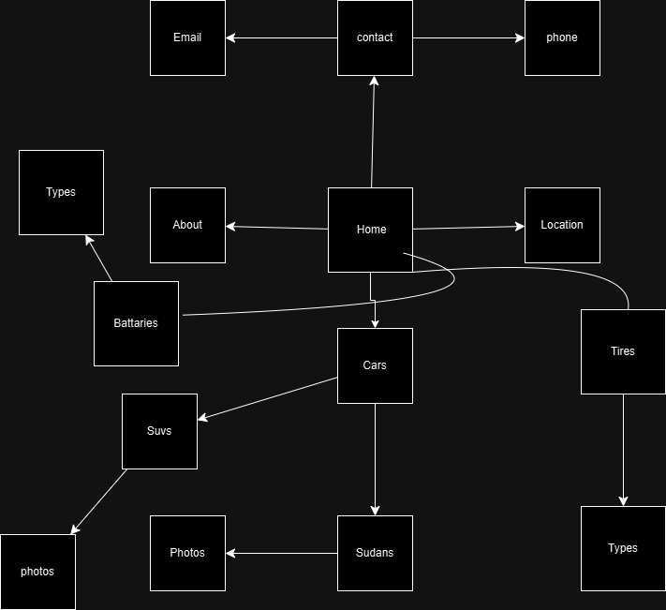

F.

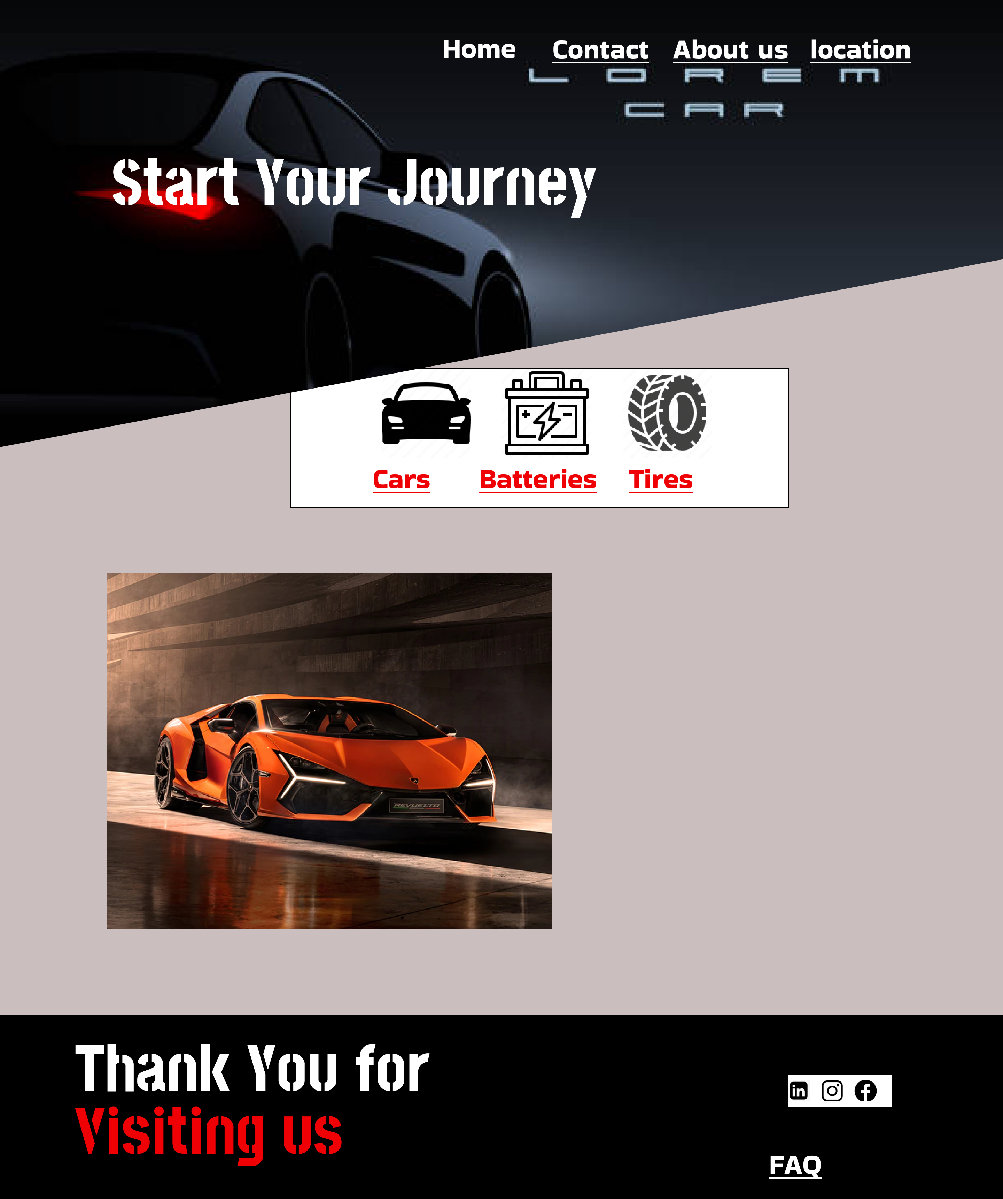

**Part 3 Website Design**

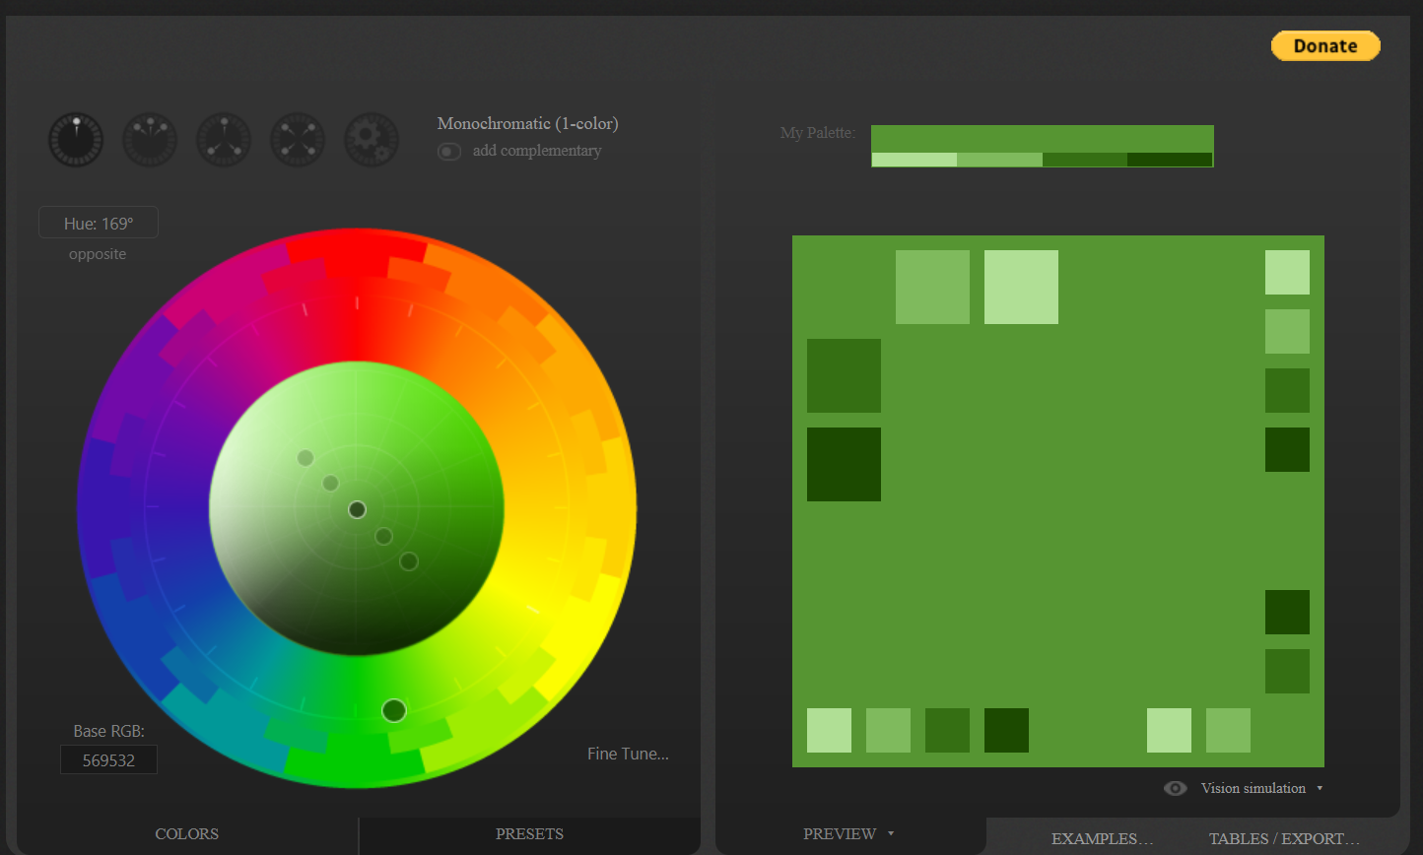

**References**

<https://acodez.in/evolution-of-the-world-wide-web/#:~:text=Web%201.0%20offered%20read%2Donly,emotional%2C%20human%2Dlike%20interface>.

<https://webapprater.com/articles/general/7-key-features-of-web-2-0.html>

<https://www.explainingcomputers.com/web2.html>

<https://helalabs.com/blog/10-key-features-of-web3-that-you-need-to-know/>

<https://www.strivemindz.com/blog/what-is-web-4-0/#:~:text=Web%204.0%20(The%20Intelligent%20Web),-Era%3A%20Web%204.0&text=This%20enables%20personalized%20experiences%2C%20efficient,interactions%20more%20personalized%20and%20efficient>

<https://www.indeed.com/career-advice/finding-a-job/social-networking>

<https://www.brandignity.com/2011/03/reasons-why-social-media-is-more-important-than-ever/#:~:text=Social%20media%20connects%20people%20globally%20by%20breaking%20down%20geographical%20barriers,from%20all%20over%20the%20world>.

<https://www.bigtrunk.co.in/what-is-social-bookmarking-and-why-it-is-important-in-seo/>

<https://www.clearpeople.com/blog/what-is-collective-intelligence-workplace#:~:text=Collective%20intelligence%20improves%20creativity%20and,it%20improves%20the%20group%20intelligence>.

<https://themyouandme.com/blog/top-5-reasons-why-technology-is-important-in-business#:~:text=Efficiency,the%20business%20to%20grow%20rapidly>.

<https://www.flexjobs.com/blog/post/how-to-answer-how-do-you-stay-current-with-new-technology/>

<https://www.figma.com/design/Bd9g4ojmucgAAOTAAjxcJF/BTC-Motors?node-id=37-119&t=eOJko9BSzp678977-1>